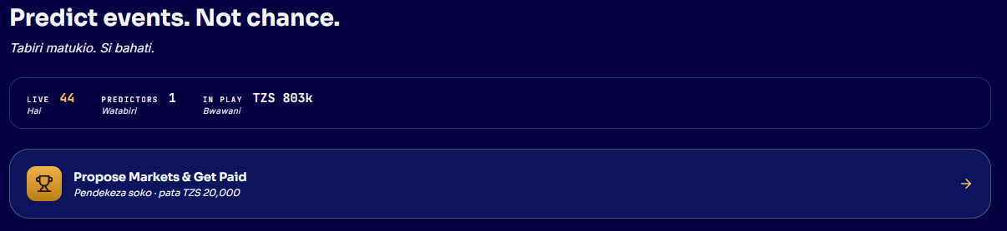
This should be removed, We can keep this in homepage
Can we keep this at the left side as column

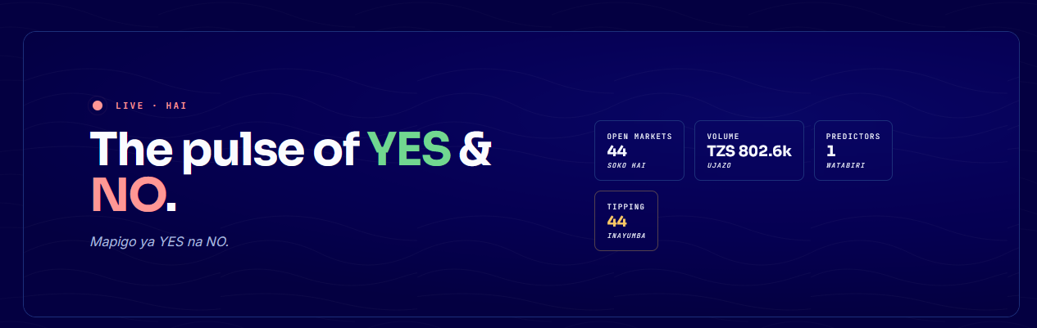
Remove this as well or maybe in Home page would be better
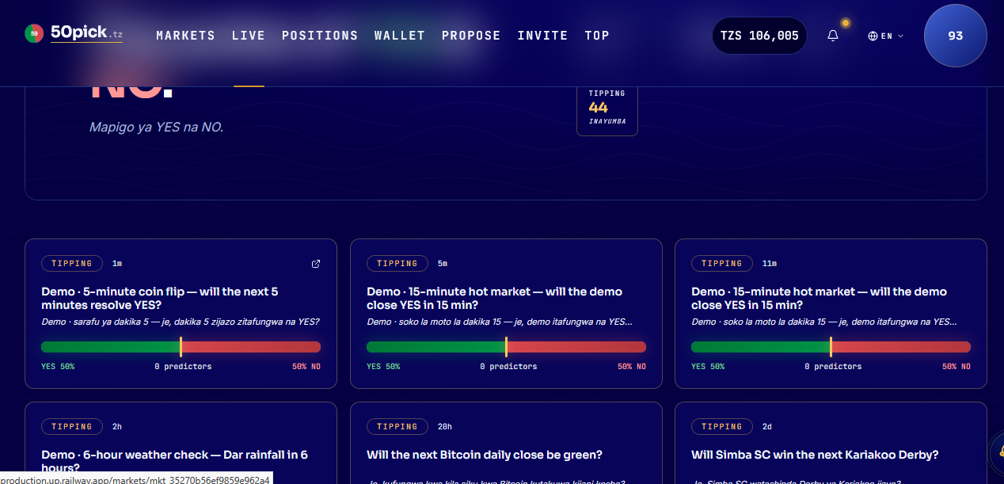
As soon as the live tab is clicked, it should show the questions straight away not with the details of total predictors and etc.

